Lysosomal Storage Disorder Newborn Screening

in Mainland China
Yvette Yao September 28, 2026
1 Introduction: Population, Rare Diseases, and the Healthcare Environment 3
1.1 Mainland China Population 3
1.2 The healthcare environment 3
1.3 Rare disease policy and expansion of newborn screening 6
2 The Chinese Diagnostics Market 7
2.1 Laboratory departments are moving from revenue centers to cost centers 8
2.2 Laboratory services face pressure to lower costs and improve efficiency 8
2.3 Implications for diagnostic market 8
3 The Landscape of LSD Patients in China 9
3.1 Results from regional newborn screening programs 10
3.2 Disease mix and geographic distribution 12
3.3 Theoretical annual identification under nationwide screening 12
3.4 Diagnostic delays, misdiagnosis, and the undiagnosed gap 14
4 Diagnosis and Treatment of LSD in China 14
4.1 Development of the clinical framework 14
4.2 Diagnostic pathway 14
4.3 Available treatments 15
4.3.1 Drugs available in China 16
4.3.2 Where screening and care are delivered 17
5 Health Economics and Payment for LSD Care 17
5.1 Diagnostic costs 17
5.2 Treatment costs 18
5.3 Public financing and additional provincial support 19
6 Feasibility of LSD Screening in China 19
6.1 Market size 19
6.2 Expert consensus 19
6.3 Policy trends 20
6.4 Policy support 20
6.5 The value of LSD early diagnosis inChina 20
6.6 LDT and commercial limitations 21
6.6 Current Products in the Market 21
7 Mainland China Market Entry Strategy 23
7.1 The Necessity of Local Operations 23
7.2 Registration pathways and regulatory requirements 23
7.3 Clinical evidence and manufacturing 24
7.4 Commercial entry 25

1 Introduction: Population, Rare Diseases, and the Healthcare Environment

1.1 Mainland China Population
China’s administrative framework includes 34 provincial-level jurisdictions. For commercial planning, mainland China is generally treated separately from Hong Kong, Macao, and Taiwan because they operate under different regulatory and administrative systems. This report will focus on mainland China.
Mainland China comprises 31 provincial-level regions, the highest level of local administration and broadly equivalent to the state level for a U.S. At the end of 2025, mainland China had a population of 1.41 billion, with 7.92 million births in this year. Although the number of births has been declining by around 1% in recent years, China still has the second-highest number of births in the world—more than twice as many as the United States. The government is introducing policies to encourage families to have more children.
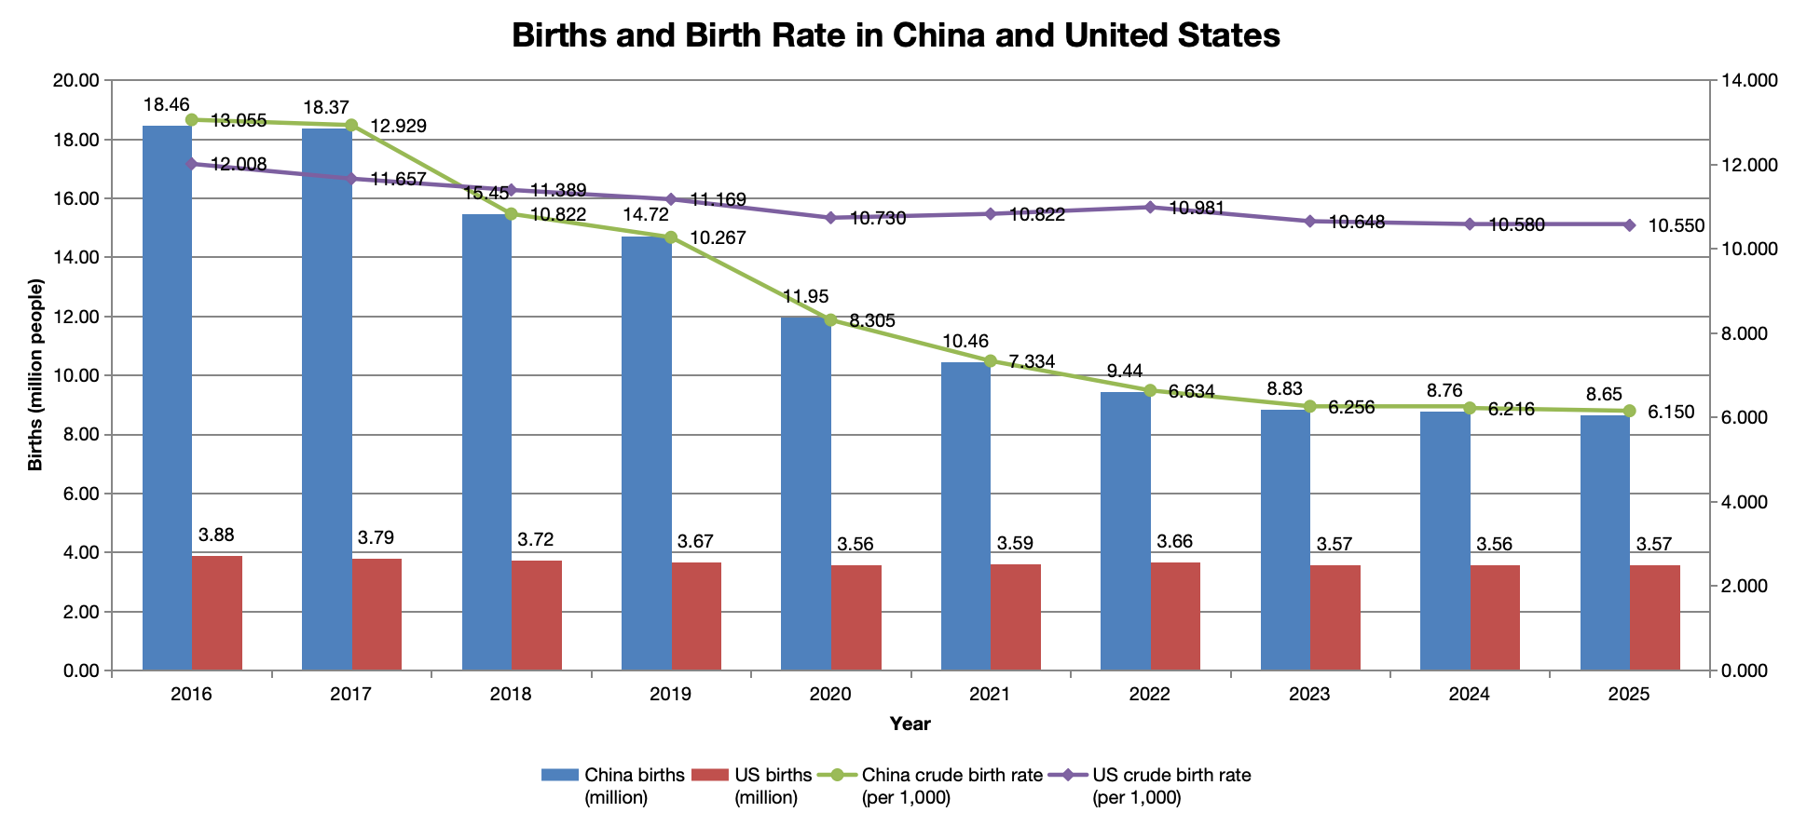
Figure 1 Births and birth rates in China and the United Statesource

1.2 The healthcare environment

1.2.1 Healthcare delivery
China classifies hospitals into three tiers: primary (Tier I), secondary (Tier II), and tertiary (Tier III), with additional assessment grades, A, B and C, within each tier. Tertiary Grade A hospitals, commonly known as “3A hospitals,” represent the highest category in this classification system.
Hospitals at different tiers serve broadly different functions. Primary hospitals provide basic local care and treat common conditions. Secondary hospitals offer a broader range of general, inpatient, and specialist services and may also receive patients transferred from tertiary hospitals for recovery and rehabilitation. Tertiary hospitals manage critical illness, complex conditions, and rare diseases, while also undertaking substantial clinical research, medical education, and technical support for other providers. Tertiary Grade A hospitals generally have a greater concentration of specialists and diagnostic resources. However, access to high-quality care remains geographically uneven. Resources are concentrated in economically developed regions such as Beijing, Shanghai, and Zhejiang, while some tertiary hospitals in central and western China and in cities outside provincial capitals still have more limited capabilities.
National policy promotes a tiered care and referral system, encouraging patients to seek initial care locally and move between institutions according to clinical need. Nevertheless, many patients seek care directly at higher-tier hospitals rather than first obtaining a referral from a primary care clinician. In this context, “primary care clinicians” refers to practitioners in China’s local healthcare network, including community health centers, township health centers, and village clinics. Their responsibilities include treating common conditions, preventive care, and chronic disease management. China’s primary care network should not be assumed to have the same resources or referral role as U.S. primary care practices.
For a sense of scale, tertiary hospitals accounted for 28.3% of all medical visits nationwide in 2024, while their bed occupancy rate was 89.6%, compared with 73.1% at secondary hospitals and 53.6% at primary hospitals. Overall, local healthcare institutions deliver a substantial volume of basic care, while rare disease expertise, advanced diagnostics, and clinical research resources remain concentrated in large tertiary hospitals.
A healthcare initiative therefore typically begins with tertiary Grade A hospitals in provincial capitals or economically developed regions, where specialist collaboration, clinical validation, and evaluation of suspected cases can be established. It then expands through their relationships with local hospitals and primary care institutions. Achieving broad regional coverage quickly requires these local providers to implement standardized procedures consistently, organize patient outreach and participation efficiently, and deliver the basic assessment and ongoing care needed to support the program.

1.2.2. Healthcare payment
Unlike the United States has a multipayer system built around employer-sponsored coverage and other private plans, China’s system is organized around public basic medical insurance, a second layer of catastrophic medical expense coverage, and means-tested medical assistance, with commercial health insurance providing supplemental coverage. The first three layers are government led; commercial insurance is a supplementary market product.
A complete pathway from screening to diagnosis and treatment requires each stage of payment to connect with the next. Screening is usually supported by public health funding or local government budgets. Repeat testing and diagnostic confirmation need to fall within reimbursable medical services. Treatment drugs need to be included in the National Reimbursement Drug List (NRDL) and actually available at hospitals, while long term follow up requires outpatient coverage. A gap in payment at any stage can interrupt the development of a disease screening and care program. For companies that want to enter China’s healthcare market, this means that widespread adoption of a product depends not only on its clinical value but also heavily on national health insurance policies, reimbursement coverage, and the government’s healthcare priorities.

Public medical coverage
Public programs primarily pay for listed drugs, tests, and medical services that meet the applicable coverage conditions. Patients remain responsible for deductibles, coinsurance, amounts above benefit caps, and noncovered expenses. At the end of 2025, approximately 1.331 billion people were enrolled in basic medical insurance, maintaining coverage at about 95% of the population.
Within this national framework, screening programs, fee schedules, and benefit levels still differ locally. Some insurance benefits must be assessed at the city level or within the relevant insurance pooling jurisdiction—the geographic area that administers the insurance fund and its benefits. Hospitals and screening centers select products and organize testing under the applicable local policies and procurement rules.

Basic medical insurance
The two main programs are Employee Basic Medical Insurance, which covers employed people, and Urban–Rural Resident Basic Medical Insurance, which covers children, students, and other residents outside the employee program. In 2025, the funds paid 84.1% and 66.0%, respectively, of eligible inpatient expenses. Children generally enroll in the resident program, so the latter is the more relevant benchmark for pediatric care

Critical illness insurance
This second public insurance layer further reduces high medical expenses after basic insurance has paid. Once a patient’s cumulative eligible out-of-pocket expenses exceed the locally specified threshold, catastrophic coverage pays a further percentage. The reimbursement share is generally 60%–70% or higher, depending on local policy. This is expense-based coverage, distinct from the lump-sum critical illness benefits familiar in the United States.

Medical assistance
Medical assistance supports low-income households, people in extreme hardship, and households impoverished by illness. It works in two ways: 1) First, it fully or partially subsidizes the resident insurance premium for eligible people. 2) after basic insurance and catastrophic coverage have paid, it covers a specified share of remaining eligible inpatient and designated chronic or serious outpatient expenses at contracted providers. Where direct settlement is available, that assistance is deducted at the hospital payment counter.
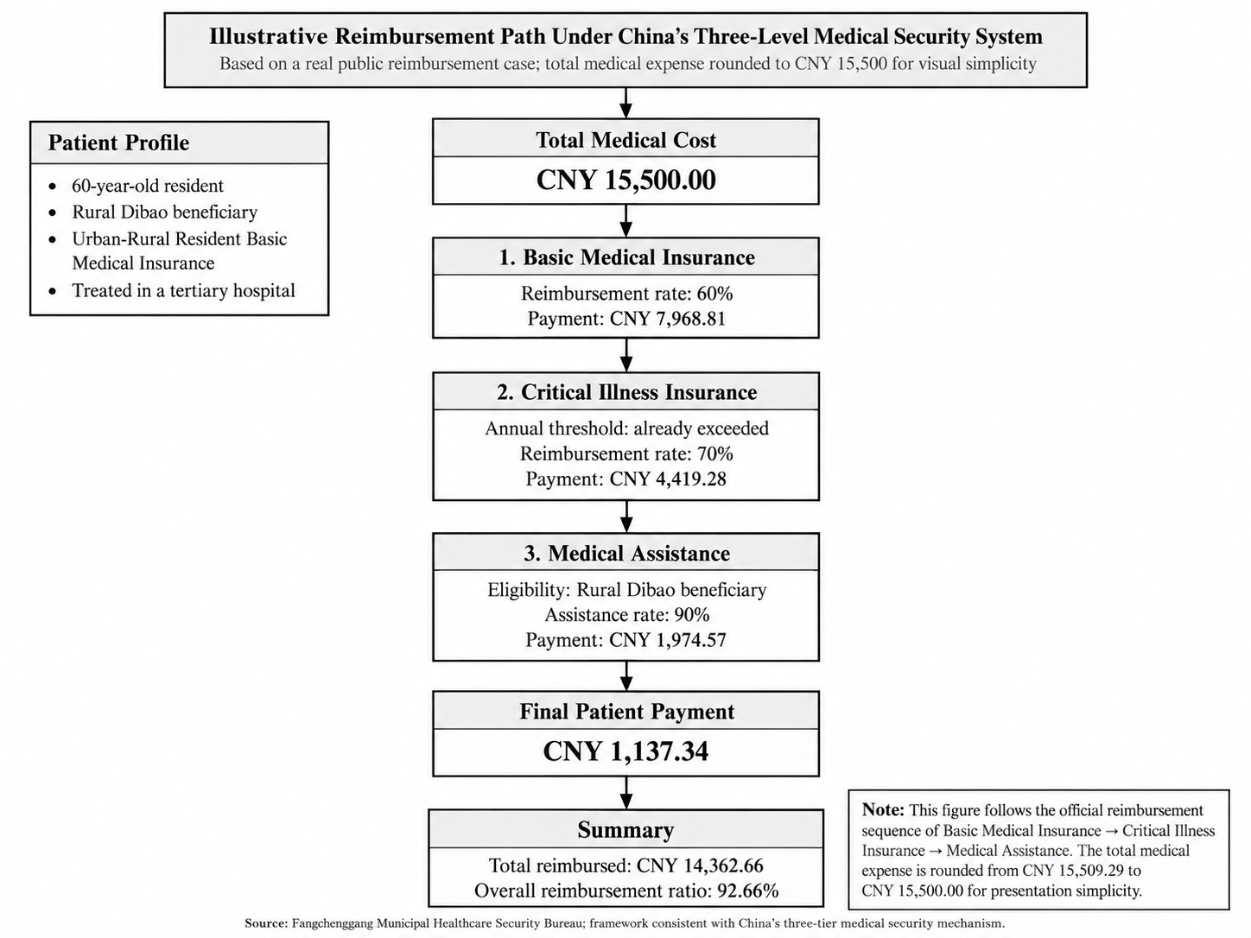
Figure 2 An illustrative public reimbursement pathway

Commercial health insurance
Individuals or employers purchase commercial health insurance voluntarily to supplement drugs, services, and high expenses that basic insurance does not cover adequately. It does not provide China’s core universal coverage. Some policies offer substantial reimbursement for drugs on the Commercial Health Insurance Innovative Drug List. Mid- and high-tier plans purchased before illness may reimburse up to 100% of eligible expenses; government-guided city-based supplemental commercial plans, often called Huiminbao, may offer people with pre-existing conditions reimbursement around 30%.

1.2.3 Product and service access, pricing, and payment
Public medical insurance mainly pays for drugs, medical services, and medical consumables, each with a different access, pricing, and payment process. Imported products generally leave patients with higher costs after reimbursement than domestic alternatives in the market considered here.

Drugs
China negotiates drug prices and national coverage through the NRDL. In 2024, drugs successfully added through negotiation or competitive bidding received an average price reduction of 63%. Patients then receive reimbursement under the rules of their insurance jurisdiction, combining a lower negotiated price with insurance payment. For example, a drug costing ¥ 100,000 a year would cost ¥ 37,000 after a 63% reduction. If local insurance then paid 70%, the patient’s theoretical annual share would be ¥ 11,100. This example illustrates the mechanism; actual expenses also depend on the covered indication, deductible, benefit cap, and local policy.

Medical services
Examinations, laboratory tests, procedures, and treatments are generally billed as medical service items. The National Healthcare Security Administration(NHSA) publishes guidelines that standardize service names and pricing rules. Provincial authorities then establish actual charges and determine local insurance coverage. A new test’s registration with the National Medical Products Administration(NMPA), therefore does not means a hospital can establish billing code or insurance reimbursement.
The 2026 laboratory service pricing guidelines also apply tiered discounts to qualifying combined tests: up to five analytes are charged at 80% of the sum of the individual prices; six to ten at 70%; and more than ten at 60%. A panel of more than ten analytes with individual charges totaling ¥ 1,000 would therefore be billed at ¥ 600, a 40% reduction.

Medical consumables
Prices for consumables are controlled through provincial procurement platform listings, centralized volume-based procurement, and insurance payment standards. Some basic consumables are already included in the medical service fee and cannot be billed separately. Certain consumables or diagnostic reagents may be charged separately, generally at the actual acquisition price.
In national centralized procurement of high-value medical consumables, selected products have achieved average price reductions of 70%. Earlier national procurement rounds covering eight categories, including coronary stents and artificial joints, achieved average reductions of more than 80%.

1.3 Rare disease policy and expansion of newborn screening
China has an estimated 20 million people living with rare diseases, and publicly reported estimates suggest that more than 200,000 affected children are born each year. The first and second national Rare Disease Lists, issued in 2018 and 2023, cover 207 conditions in total. These lists help define the policy scope for diagnosis, treatment, drug review, and medical coverage. The number of rare disease drugs in the NRDL increased from 39 in 2018 to 121 in 2025, approximately 3.1 times the earlier total. This reflects growing support for rare disease care as economic capacity improves and policy places greater emphasis on healthy births and children’s long-term health.
In 2025, China also introduced the Commercial Health Insurance Innovative Drug List. Its first edition included 19 drugs with substantial clinical value whose cost was beyond the basic public insurance benefit package. This provides an additional market access and payment route for certain high-cost rare disease therapies.
Alongside improved treatment coverage, child health policy is moving earlier in the care pathway, toward prevention of birth defects and early detection. The National Program for Child Development 2021–2030 covers premarital, preconception, prenatal, and postnatal care and calls for a broader newborn screening panel. Coverage now exceeds 98% for both the core inherited and metabolic newborn screening program, centered on phenylketonuria (PKU) and congenital hypothyroidism (CH), and newborn hearing screening. These established programs provide a mature national service network. The Plan to Improve Birth Defect Prevention and Treatment Capacity 2023–2027 further encourages regions with sufficient resources to add screening conditions. Beijing, Shanghai, and Zhejiang have expanded their publicly funded panels to 12, 15, and 29 conditions, respectively.
Two connected developments are taking shape: 1) Public and commercial insurance are improving access to treatment after diagnosis, while broader newborn screening is moving identification before symptoms appear. 2) With basic screening coverage approaching saturation, further growth is more likely to come from additional conditions, upgrades to regional programs, and better connections among screening, diagnosis, payment, and treatment.

2 The Chinese Diagnostics Market
Before examining the market, it is useful to understand how responsibilities are divided. National agencies establish the principal regulatory and policy framework; provinces, cities, and individual medical institutions put it into practice. Companies entering China need to distinguish product approval, screening program administration, medical service pricing, and insurance payment. The main agencies are:
National Medical Products Administration (NMPA). Registers and regulates drugs and medical devices, including in vitro diagnostic reagents. Its medical product regulatory role is broadly comparable to that of the U.S. FDA.
Center for Medical Device Evaluation (CMDE). NMPA’s technical review body for medical devices and relevant IVD registration applications. It is a key point of contact for discussing product performance, clinical evidence, and technical registration requirements.
National Health Commission (NHC). Oversees health policy and the healthcare delivery system, including maternal and child health and birth defect prevention. Local health commissions and medical institutions organize and implement newborn screening programs.
National Healthcare Security Administration (NHSA). Oversees basic medical insurance policy, reimbursement lists, and payment management, and guides medical service pricing and procurement of drugs and medical consumables.
Population aging, chronic disease management, early cancer detection, birth defect prevention, and precision medicine continue to generate substantial demand for testing in mainland China. The domestic IVD reagent market is estimated at approximately ¥ 130 billion in 2025.
China’s healthcare market is undergoing a major change in direction. National policies and healthcare reforms are shifting the focus from adding billable services and expanding treatment volume toward clinical value, cost control, and testing efficiency.
The resulting disruption has left the IVD market subdued, with substantial technology turnover and new competitive pressures. China’s pace of production and innovation nevertheless keeps competition intense. Industry participants generally see the market as being near the bottom of the current healthcare cycle, with a recovery likely only after this restructuring has run its course. The next few years are therefore better viewed as a period in which to lay the groundwork for new technologies.

2.1 Laboratory departments are moving from revenue centers to cost centers
China launched national DRG pilots in 2019, followed by DIP pilots in 2020, and expanded these payment reforms nationally during 2022–2024. Under case-based inpatient payment, laboratory testing becomes part of the total cost of an admission, rather than simply another separately billable source of revenue. Hospitals therefore examine the need for a new test more closely. Tests that reduce misdiagnosis or repeat testing, support earlier treatment decisions, shorten hospital stays, or avoid ineffective medication still offer clear value.
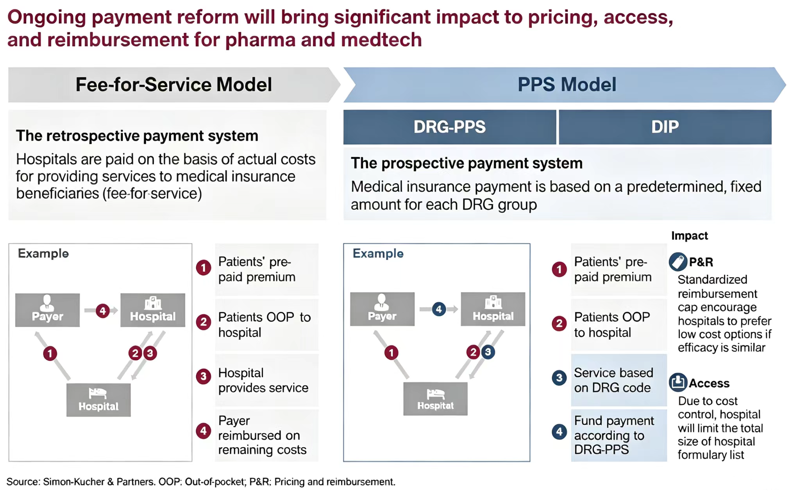
Figure 3 Hospital payment reform and its implications

2.2 Laboratory services face pressure to lower costs and improve efficiency
In 2026, NHSA issued the Guidelines for Establishing Laboratory Medical Service Price Items, directly reshaping test charges and hospitals’ technology choices. The framework standardizes service names, test content, billing units, and service codes, consolidating more than 2,000 existing items into 662 main items. In principle, the same test is no longer priced separately by methodology, although specified add-on charges can reflect the cost of mass spectrometry, quantitative testing, or confirmatory procedures. The aim is to support mutual recognition of test results, curb irregular charging, and reduce opportunities for opaque profits outside hospitals.
This method-neutral pricing approach is accompanied by tiered discounts for combined testing: up to five analytes are charged at 80% of the sum of individual prices; six to ten at 70%; and more than ten at 60%.
Hospitals will consequently place more weight on cost per test, staff time, and actual clinical output when adopting a technology. Companies will have less room to justify a premium solely on the basis of technical complexity.

2.3 Implications for diagnostic market
These policies reduce the scope for premium pricing based only on differences in routine testing technology. Routine chemistry and immunoassay reagents will compete increasingly on cost, consistency, instrument compatibility, and reliable supply. Genetic, oncology, and rare disease tests must demonstrate clinical value while also securing product registration, a billable service item, hospital adoption, and a payment source.
For qualifying products with substantial clinical value, NMPA has established a Special Review Procedure for Innovative Medical Devices and published registration review guidance for devices used in rare disease prevention and treatment. These mechanisms can support earlier regulatory communication and a more tailored review. Where patient numbers are small and enrollment is difficult, conditional approval with additional postmarketing clinical evidence may be explored if the available evidence supports a favorable benefit–risk assessment.

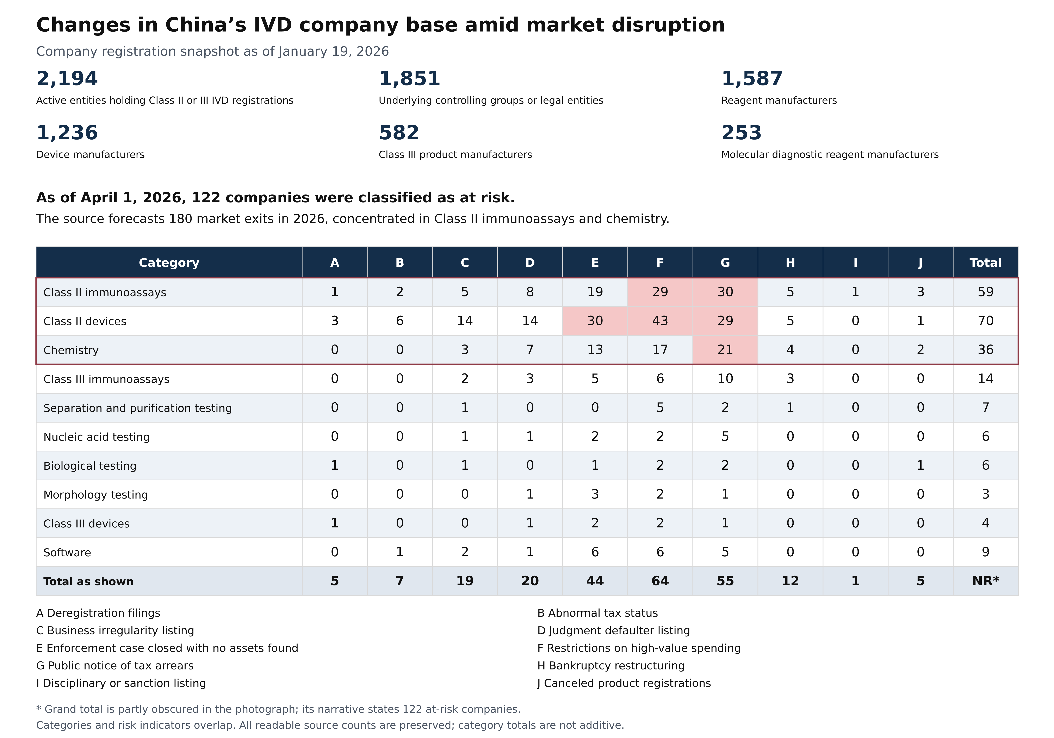
Figure 4 The Chinese IVD company base and reported financial risk indicators

3 The Landscape of LSD Patients in China
Mainland China has not yet established nationwide LSD newborn screening or a population database published on a unified basis by national authorities. Available large-scale preliminary screening evidence places newborn LSD incidence at approximately 1 in 7,000–8,000, including Gaucher disease at about 1 in 50,000, Pompe disease at about 1 in 20,000, and Niemann–Pick types A/B at about 1 in 10,000. Comparative evidence also indicates higher frequencies of Fabry and Pompe disease in some Asian populations than in Western populations.

Disease and gene | Population with higher reported frequency | Incidence or prevalence comparison in the source | Genetic or clinical context
Fabry disease  GLA | East Asian populations | East Asia: approximately 1 in 1,250–1,600 male births.  Western populations: approximately 1 in 22,000–40,000 male births. | High frequencies in some East Asian cohorts are associated with the founder variant IVS4+919G>A and late-onset cardiac Fabry disease.
Pompe disease  GAA | East Asian populations | East Asia: approximately 1 in 16,000–20,000 live births.  Western populations: approximately 1 in 40,000. | Severe infantile-onset Pompe disease (IOPD) is particularly prominent in southern China and Taiwan, associated with specific genetic variants.
Gaucher disease  GBA | Western populations, especially Ashkenazi Jewish populations | Western populations: approximately 1 in 40,000–60,000; about 1 in 800 among Ashkenazi Jewish people.  Asia–Pacific: fewer than 1 in 100,000. | Non-neuronopathic type 1 is particularly associated with Western and Ashkenazi Jewish populations. Among Asian patients, neuronopathic type 3 accounts for a larger proportion of the disease mix.
Krabbe disease  GALC | Western populations | Western populations: approximately 1 in 100,000 live births.  East Asia: clinically recognized cases are very uncommon. | A common 30 kb deletion in people of European ancestry contributes to the higher frequency of severe infantile disease in Western populations.
Niemann–Pick A/B  SMPD1 | Some Western and Middle Eastern populations | Western populations: approximately 1 in 100,000–250,000 live births.  East Asia: a consistently low background frequency. | Type A carrier frequency is higher in Ashkenazi Jewish populations. Both types remain rare in Asia.
MPS I  IDUA | Western populations | Western populations: approximately 1 in 100,000 live births.  East Asia: approximately 3.7% of reported MPS cases. | MPS I is more prominent in Europe and the United States. MPS II (Hunter syndrome) predominates in the Asian MPS disease mix cited in the source, accounting for more than 50% of cases.
Table 1 Population differences in the six principal LSDs

3.1 Results from regional newborn screening programs
LSD newborn screening in China currently follows two main technical approaches. The first is enzyme activity testing by MS/MS, typically a four-plexpanel for Gaucher, Fabry, Pompe, and MPS I, or a six-plexpanel that adds Niemann–Pick A/B and Krabbe disease. The second incorporates LSD genes into broader genetic newborn screening panels.
Most available evidence comes from a limited number of regional studies and pilot programs in places such as Shanghai, Shandong, Fujian, and Nanjing. These programs are concentrated in areas with stronger finances, screening infrastructure, and specialist diagnostic resources.
Across mainland six-plex enzyme screening cohorts, reported study-endpoint identification rates are approximately 2.82–5.39 per 10,000 newborns. Genetic screening cohorts report presymptomatic confirmation or symptomatic diagnoses during follow-up at approximately 3.38–6.61 per 10,000. Both approaches point to several LSD-related individuals identified for every 10,000 newborns screened. Differences depend on assay cutoffs, repeat testing, genetic confirmation criteria, classification of variants of uncertain significance (VUS), and completion of follow-up. These yields generally exceed consensus incidence estimates. One possible explanation is that research programs recruit a higher proportion of newborns with clinical findings; this may also make them more representative of an initial market entry through research partnerships.
Evidence type | Program and institution | Panel | Reported yield per 10,000 | Disease-specific findings | Method, instrument, and kit
Mainland  Enzyme NBS | Shanghai six-plex screening; Shanghai Institute for Pediatric Research; specimens from 41 maternity hospitals | Gaucher, ASMD, Krabbe, MPS I, Fabry, Pompe | 5.39  1 in 1,856 | Gaucher 2 (1 in 25,054); ASMD 5 (1 in 10,022); Krabbe 9 (1 in 5,568); MPS I 0; Fabry 8 (1 in 6,264); Pompe 3 (1 in 16,702) | MS/MS; PerkinElmer NeoLSD MSMS Kit; QSight 210 MD
Mainland  Enzyme NBS | Six-city Shandong six-plex program; Shandong Newborn Screening Center | Gaucher, ASMD, Krabbe, MPS I, Fabry, Pompe | 2.82  1 in 3,540 | Krabbe 5; Fabry 3; Pompe 3 | MS/MS; Waters Xevo TQD; PerkinElmer NeoLSD MSMS Kit
Mainland  Enzyme NBS | Jinan cohort of 26,689; Jinan Maternal and Child Health Hospital and Newborn Screening Center | Gaucher, ASMD, Krabbe, MPS I, Fabry, Pompe | 3.00  1 in 3,336 | Pompe 3; Krabbe 3; Fabry 2 | MS/MS; Waters Xevo TQD; PerkinElmer NeoLSD MSMS Kit
Mainland  Enzyme NBS | Fujian cohort of 3,000; Medical Genetics Center of Fujian Maternity and Child Health Hospital and Fujian CDC | Gaucher, ASMD, Krabbe, MPS I, Fabry, Pompe | 3.33  1 in 3,000 | Pompe 1 | MS/MS
Mainland  Genetic NBS | Nanjing 15-LSD genetic screening; Nanjing Maternity and Child Health Care Hospital | 15 LSDs and 18 genes, including Fabry, Krabbe, Pompe, Niemann–Pick, and MPS II | 6.61  1 in 1,512 | Fabry 5; Krabbe 8; Pompe 1; Niemann–Pick 1 | Target-capture NGS; NeoLSD MSMS Kit in a 900-sample subset
Mainland  Genetic NBS | Yunnan cohort of 3,001; First People’s Hospital of Yunnan Province | Full project: 156 diseases/159 genes; explicit LSD-specific findings limited to Niemann–Pick A/B | 10.00  1 in 1,000 | Niemann–Pick A/B 3 | Traditional biochemical NBS +targeted genetic NBS
Mainland  Genetic NBS | Eight-center first-tier genetic screening: Shanghai, Guangzhou, Shijiazhuang, Yunnan, Chongqing, Inner Mongolia, Jinan, and Hainan | 128 diseases/142 genes; LSD-specific reporting for Niemann–Pick A/B, Krabbe, and Fabry | 4.39  1 in 2,277 | Niemann–Pick A/B 6; Krabbe 4; Fabry 3 | Targeted DBS gene panel + concurrent biochemical NBS
Mainland  Genetic NBS | Retrospective Zhejiang cohort of 4,986; Children’s Hospital of Zhejiang University School of Medicine; Zhejiang Newborn Screening Center; Biosan laboratory | 74 inherited diseases/134 genes | NR | NR | Multiplex PCR + NGS,
Mainland  High-risk screening | Sanofi and Beijing Dayi Public Welfare Foundation multicenter LSD program | Gaucher, Pompe, Fabry, MPS I | NR | NR | NR
External reference  Taiwan | Taiwan 8-plex screening cohort of 73,743; newborn screening network | Pompe, Fabry, Gaucher, MPS I, II, IIIB, IVA, VI, ML | 31.19  1 in 3,206 | Total 23: Pompe 4; Fabry 4; Gaucher 1; MPS I 1; MPS II 3; MPS IIIB 3; MPS IVA 6; MPS VI 0; ML 1 | MS/MS; Waters Xevo TQD; PerkinElmer 8-plex MS/MS kit
Table 2 Regional LSD newborn screening and high-risk screening evidence

3.2 Disease mix and geographic distribution
Takeda China, the producer of agalsidase α concentrate for infusion for Fabry disease, conducted a four-plex high-risk diagnostic screening program across 30 provinces over approximately one year. It recorded 634 LSD-related individuals. Fabry accounted for the largest share, at 39.1%; Gaucher and Pompe disease had similar shares; and MPS I was least frequent, at 5.4%. This provides a clear view of the disease mix among patients reached by this diagnostic program.
Shandong, Jiangsu, Zhejiang, Guangdong, and Shanghai accounted for 392 individuals, or 61.8% of the total. Patients reaching high-risk testing and diagnosis are therefore concentrated in coastal regions with stronger referral networks, specialist care, and testing capacity. This points to a practical entry strategy: begin in cities where diagnostic demand is already established.
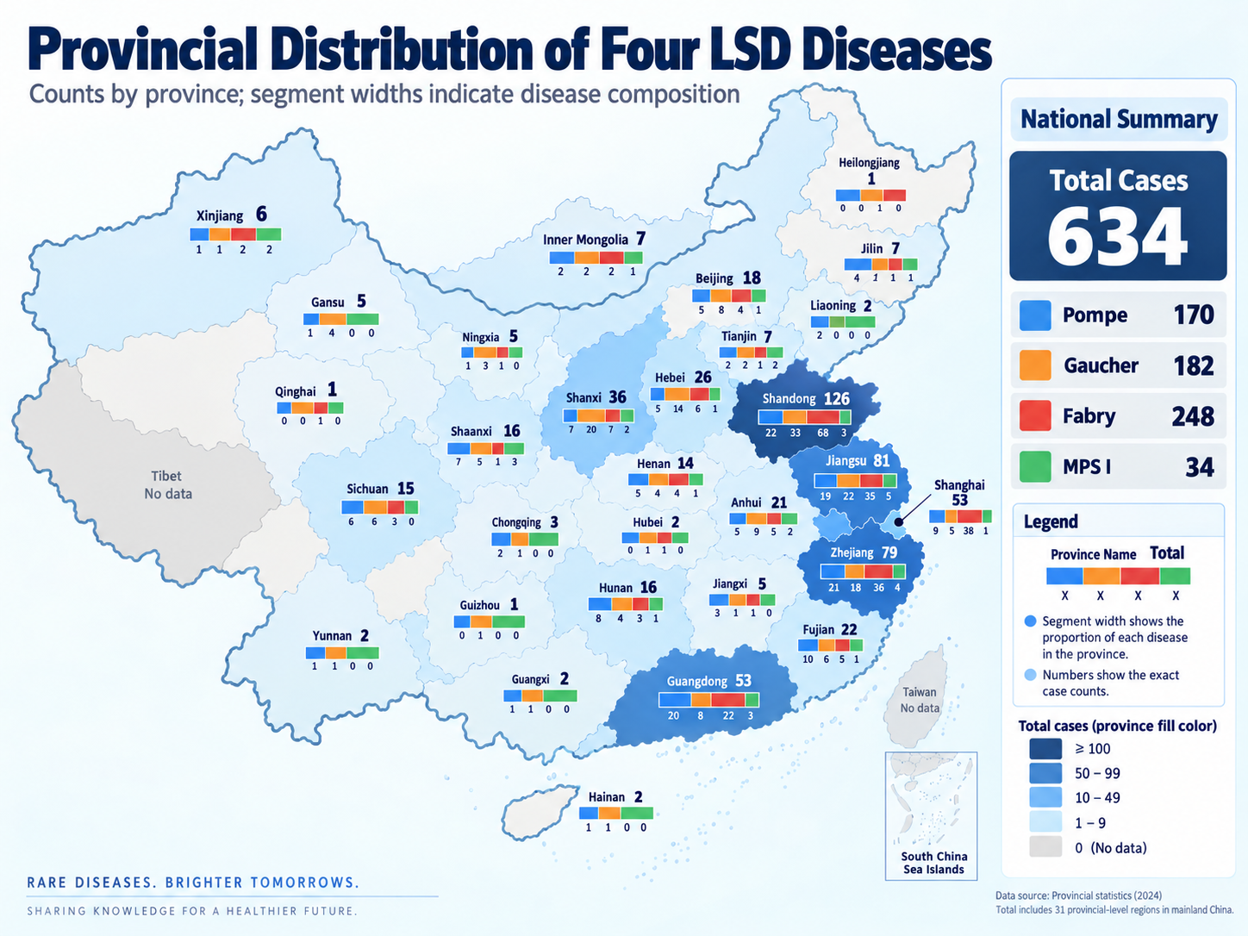
Figure 5 Provincial distribution in a four-plex high-risk screening program

3.3 Theoretical annual identification under nationwide screening
After comparing cohort size, disease coverage, screening procedures, and completeness of outcomes, we selected the Shanghai cohort as the reference for a national scenario. Applying its six-plex panel, screening thresholds, confirmation criteria, and follow-up performance to a 2025 birth base of 7.92 million, with full national coverage, gives approximately 4,268 LSD-related individuals identified annually, with a count-based interval of approximately 2,813–6,208.

Province | Birth share | 2025 birth base | Total identified | Lower count | Upper count | Gaucher | ASMD | Krabbe | MPS I | Fabry | Pompe
Guangdong | 11.90% | 940,468 | 507 | 334 | 737 | 38 | 94 | 169 | — | 150 | 56
Henan | 8.00% | 632,960 | 341 | 225 | 496 | 25 | 63 | 114 | — | 101 | 38
Shandong | 6.80% | 538,383 | 290 | 191 | 422 | 21 | 54 | 97 | — | 86 | 32
Sichuan | 5.60% | 445,191 | 240 | 158 | 349 | 18 | 44 | 80 | — | 71 | 27
Hebei | 4.60% | 361,745 | 195 | 128 | 284 | 14 | 36 | 65 | — | 58 | 22
Guizhou | 4.30% | 344,384 | 186 | 122 | 270 | 14 | 34 | 62 | — | 55 | 21
Guangxi | 4.40% | 348,819 | 188 | 124 | 273 | 14 | 35 | 63 | — | 56 | 21
Jiangsu | 4.50% | 352,489 | 190 | 125 | 276 | 14 | 35 | 63 | — | 56 | 21
Yunnan | 4.20% | 333,762 | 180 | 119 | 262 | 13 | 33 | 60 | — | 53 | 20
Zhejiang | 4.30% | 340,549 | 184 | 121 | 267 | 14 | 34 | 61 | — | 54 | 20
Anhui | 4.00% | 313,581 | 169 | 111 | 246 | 13 | 31 | 56 | — | 50 | 19
Hunan | 4.00% | 320,449 | 173 | 114 | 251 | 13 | 32 | 58 | — | 51 | 19
Hubei | 3.30% | 260,656 | 140 | 93 | 204 | 10 | 26 | 47 | — | 42 | 16
Jiangxi | 3.10% | 248,900 | 134 | 88 | 195 | 10 | 25 | 45 | — | 40 | 15
Shaanxi | 3.00% | 241,502 | 130 | 86 | 189 | 10 | 24 | 43 | — | 39 | 14
Fujian | 3.10% | 241,636 | 130 | 86 | 189 | 10 | 24 | 43 | — | 39 | 14
Shanxi | 2.50% | 199,115 | 107 | 71 | 156 | 8 | 20 | 36 | — | 32 | 12
Xinjiang | 2.60% | 204,148 | 110 | 72 | 160 | 8 | 20 | 37 | — | 33 | 12
Gansu | 2.10% | 163,478 | 88 | 58 | 128 | 7 | 16 | 29 | — | 26 | 10
Liaoning | 1.90% | 149,498 | 81 | 53 | 117 | 6 | 15 | 27 | — | 24 | 9
Chongqing | 2.00% | 158,656 | 85 | 56 | 124 | 6 | 16 | 28 | — | 25 | 9
Inner Mongolia | 1.40% | 109,615 | 59 | 39 | 86 | 4 | 11 | 20 | — | 18 | 7
Beijing | 1.40% | 110,443 | 60 | 39 | 87 | 4 | 11 | 20 | — | 18 | 7
Shanghai | 1.20% | 97,933 | 53 | 35 | 77 | 4 | 10 | 18 | — | 16 | 6
Jilin | 1.00% | 80,592 | 43 | 29 | 63 | 3 | 8 | 14 | — | 13 | 5
Hainan | 1.00% | 81,327 | 44 | 29 | 64 | 3 | 8 | 15 | — | 13 | 5
Heilongjiang | 1.10% | 84,698 | 46 | 30 | 66 | 3 | 8 | 15 | — | 14 | 5
Ningxia | 0.80% | 66,390 | 36 | 24 | 52 | 3 | 7 | 12 | — | 11 | 4
Tibet | 0.50% | 42,316 | 23 | 15 | 33 | 2 | 4 | 8 | — | 7 | 3
Qinghai | 0.60% | 49,813 | 27 | 18 | 39 | 2 | 5 | 9 | — | 8 | 3
Tianjin | 0.70% | 56,505 | 30 | 20 | 44 | 2 | 6 | 10 | — | 9 | 3
Total | 100.0% | 7,920,000 | 4,268 | 2,813 | 6,208 | 316 | 790 | 1,423 | — | 1,264 | 474
Table 3 Provincial identification scenario under full newborn screening coverage
*Theoretical annual identifications at 100% newborn screening coverage; disease mix based on the Shanghai reference cohort.

3.4 Diagnostic delays, misdiagnosis, and the undiagnosed gap
Published Chinese patient cohorts show that the time to diagnosis varies by disorder, but patients commonly develop clear symptoms and move through several specialties before reaching enzyme and genetic testing. Diagnostic delay, misdiagnosis, and undiagnosed disease are therefore widespread. Fabry and late-onset Pompe disease can remain unrecognized for years because onset is gradual and symptoms affect different organs. Gaucher disease and MPS may be diagnosed sooner, but patients still pass through multiple hospitals and incorrect diagnoses:
For Fabry disease, the mean interval from first symptoms to diagnosis was 14.48 ± 11.85 years. In late-onset Pompe disease, the median delay was five years, and 33 of 34 patients, or 97.1%, had previously been misdiagnosed. Gaucher patients had a shorter mean delay of 1.2 ± 1.7 years, but experienced an average of 5.0 misdiagnoses and attended 3.9 hospitals before diagnosis. Across MPS patients, the mean time from the first visit for relevant symptoms to diagnosis was 9.42 months, with an average of 6.31 consultations and 4.56 misdiagnoses. Among patients with MPS II, 83 of 145, or 57.2%, reported prior misdiagnosis.
China therefore has two clinically meaningful identification needs: 1) newborn screening to identify some patients at birth or before symptoms, and2) high-risk screening to shorten the diagnostic journey for people who already have clinical findings.

4 Diagnosis and Treatment of LSD in China
China has progressed from recognizing isolated LSD cases to establishing basic clinical standards. An initial collaboration model is now in place: screening centers identify potential cases > disease-specific centers confirm and classify them > tertiary Grade A hospitals provide treatment and follow-up. However, regional coverage and referral connections still have considerable room to improve.

4.1 Development of the clinical framework
- 1999–2009. Gaucher treatment evolved from charitable access to medication toward commercial availability of enzyme replacement therapy.
- 2005. Molecular classification began to be used in studies of Chinese Gaucher patients.
- 2018. Fabry disease, Gaucher disease, Pompe disease, MPS, Niemann–Pick disease, and lysosomal acid lipase deficiency entered China’s First National Rare Disease List, bringing them explicitly within the healthcare policy agenda.
- 2020. The China LSD Newborn Screening Collaborative Group was established.
- 2026. The first expert consensus dedicated to newborn screening for common LSDs further standardized screening, diagnosis, treatment, and follow-up.

4.2 Diagnostic pathway
The currently recommended basic pathway in China is: newborn dried blood spot screening → repeat testing using the original sample and recall → confirmatory enzyme activity testing → disease-specific biomarker and genetic testing → clinical classification → development of a treatment and follow-up plan.
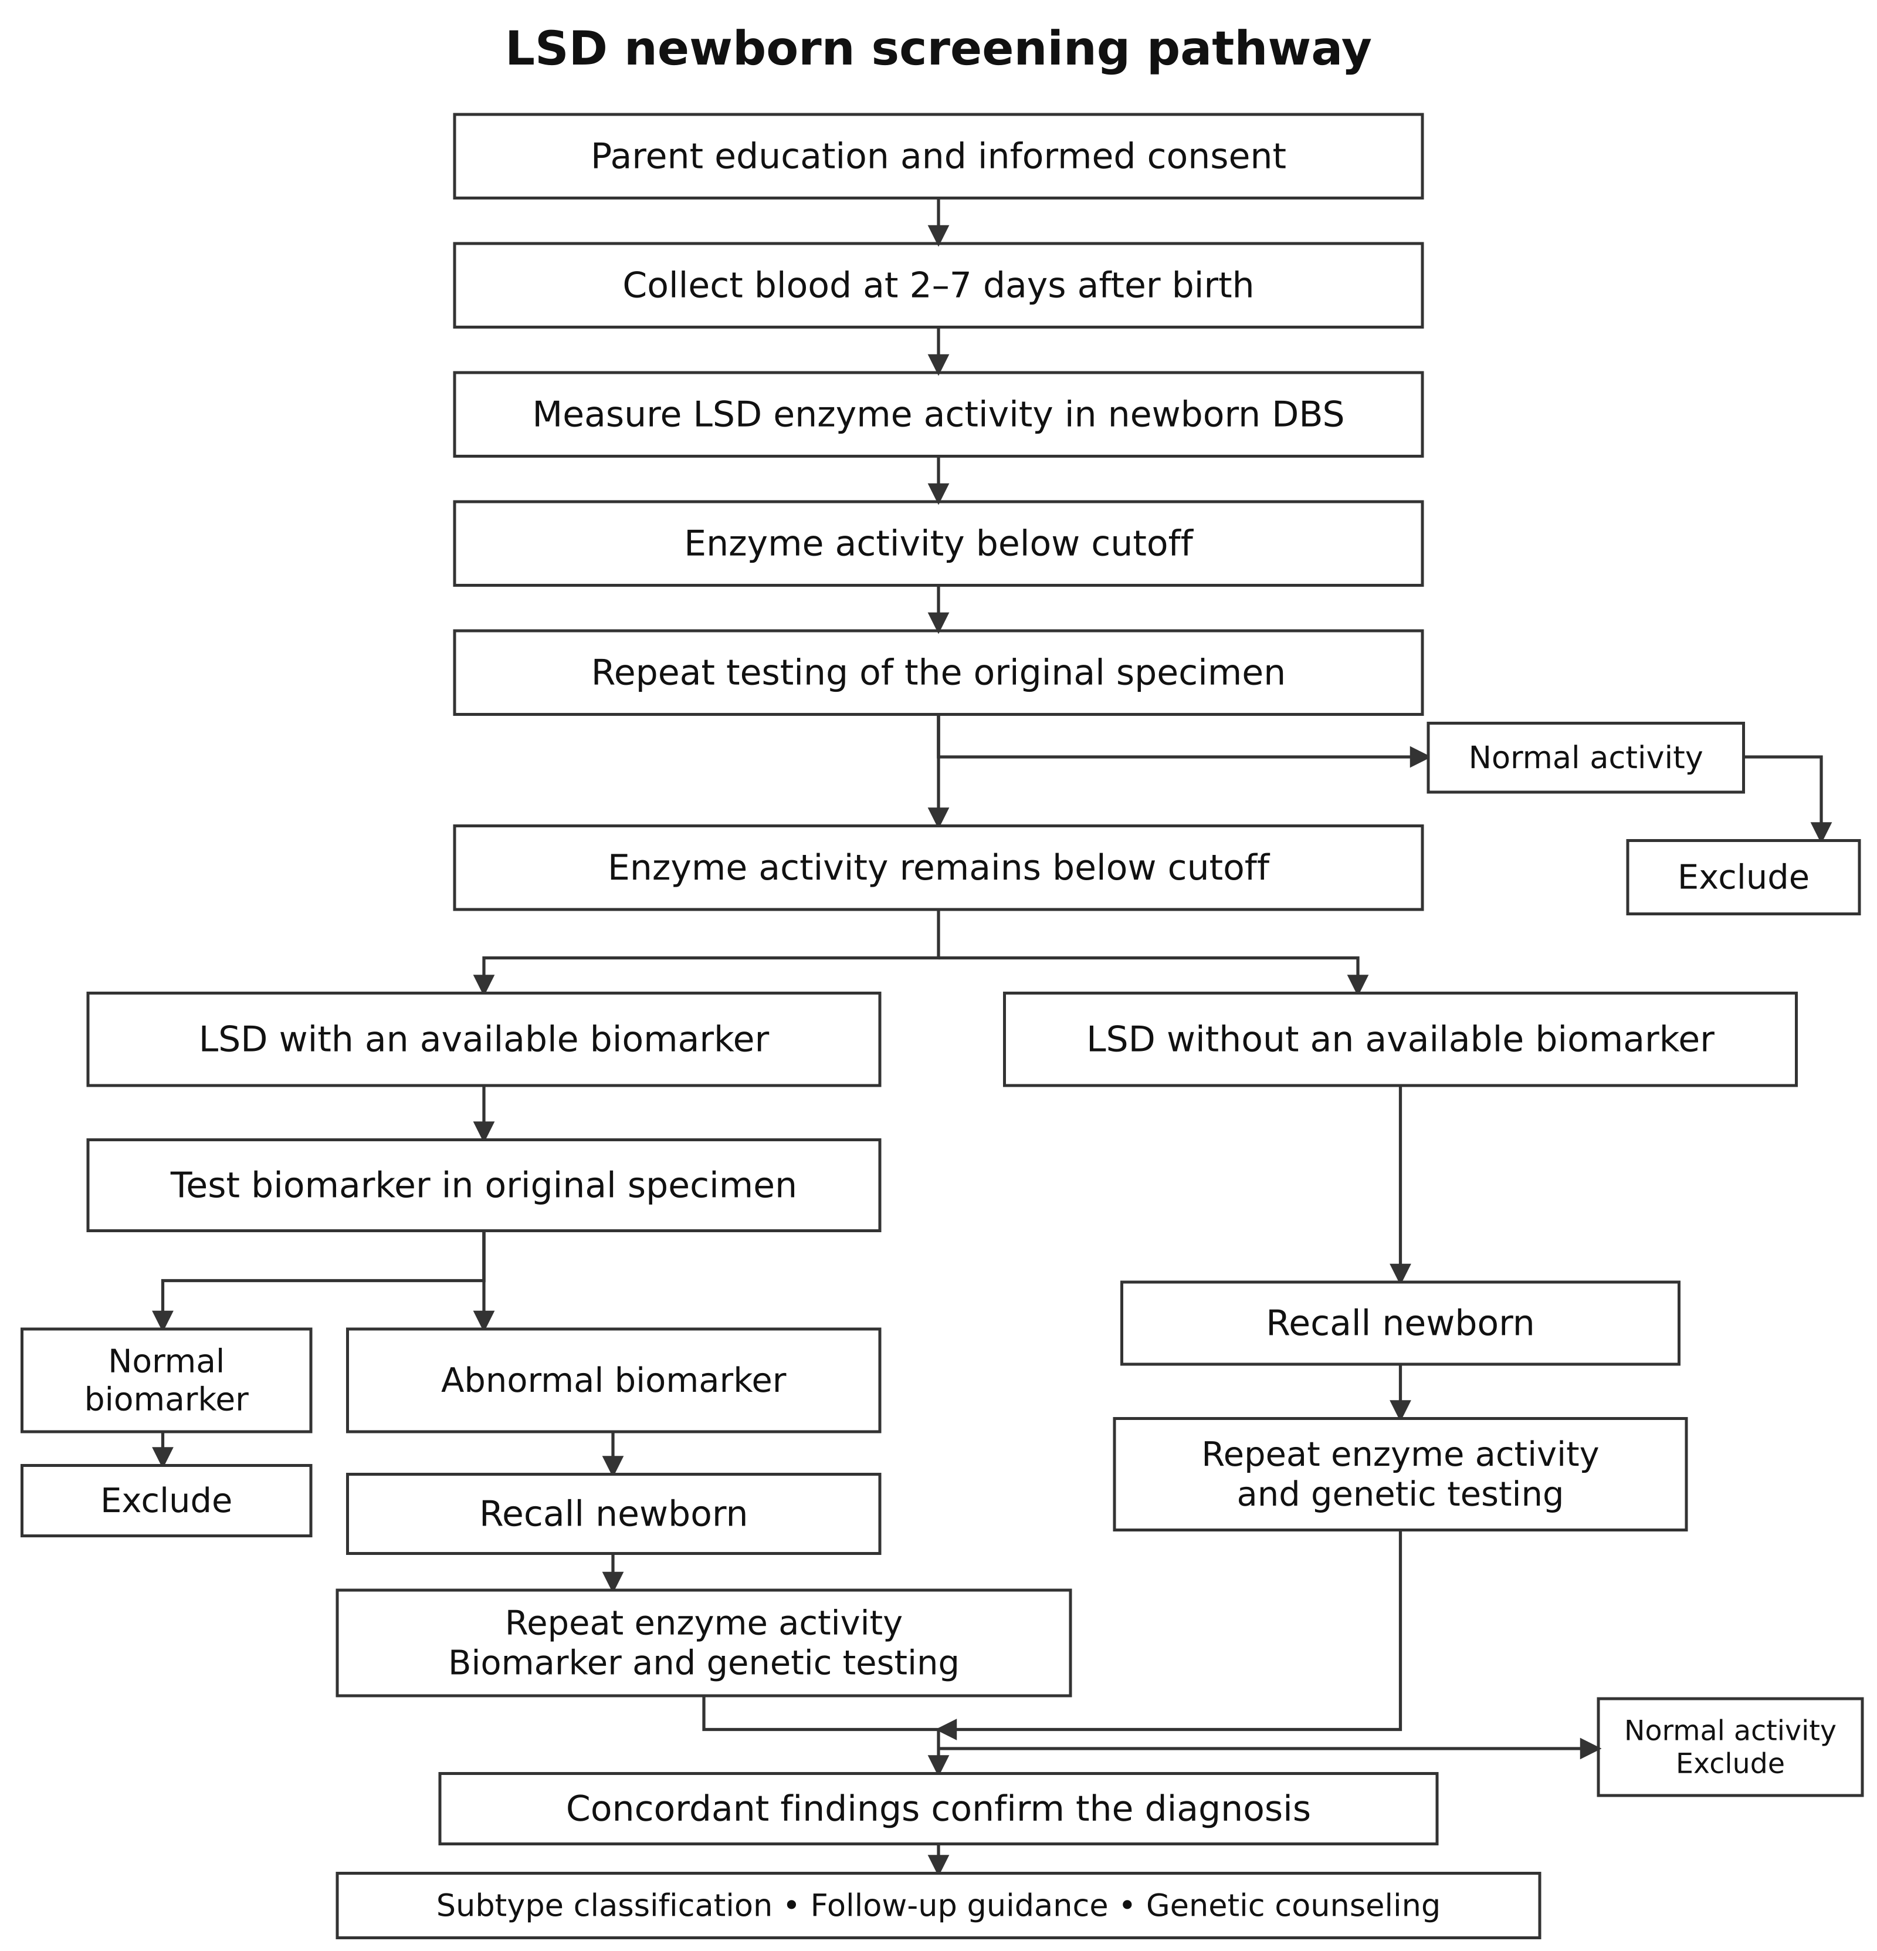
Figure 6 LSD newborn screening workflow

4.3 Available treatments
Treatment mainly involves medication or hematopoietic stem cell transplantation (HSCT), supported by rehabilitation and other measures. Medication remains the principal approach. HSCT is less common because its role is limited by disease type, risk, and cost, although several leading pediatric centers offer it. The hematology service at the Capital Institute of Pediatrics in Beijing is identified here as the most experienced center, having successfully treated 138 children with MPS between 2015 and 2025.
Treatment | Principal applications | Main limitations or role
Enzyme replacement therapy (ERT) | Gaucher types I/III; Pompe; Fabry; MPS I | Most intravenous ERT does not cross the blood–brain barrier; regular long-term infusions are required.
Small-molecule therapies | Gaucher type I; selected Fabry patients;  ambroxol and other approaches remain largely exploratory | Eligibility depends on age, genotype, or phenotype; availability in China differs by product.
HSCT | Asymptomatic or presymptomatic early-infantile Krabbe disease; severe MPS I | A narrow treatment window and transplant-related risk; limited improvement of established neurologic injury.
Symptom management and rehabilitation | All LSDs | Cardiopulmonary support, nutrition, pain control, renal replacement therapy, and motor, respiratory, hearing, and vision rehabilitation.
Table 4 Principal treatment approaches

4.3.1 Drugs available in China
Eleven drugs have entered the Chinese market for Gaucher, Fabry, Pompe, MPS types I, II, and IVA, and Niemann–Pick type C. Three have received national reimbursement coverage since 2024 and are managed through separate-payment arrangements. One entered the first Commercial Health Insurance Innovative Drug List in 2025, implemented from 2026, as an option for supplemental commercial coverage. Most LSD enzyme replacement therapies remain outside the national basic insurance formulary. Patients primarily rely on local insurance or special catastrophic-coverage arrangements, commercial health insurance, charitable assistance, or self-payment.
Separate-payment management means that designated drugs have a distinct reimbursement arrangement under local policy. Nationally negotiated payment prices may not be publicly disclosed. Most provinces supply these drugs through designated hospitals or pharmacies and may require enrollment, review of the covered indication, or an annual payment limit. Reimbursement shares and patient spending limits vary locally. It is distinct from “dual-channel” dispensing, which refers to access through both hospitals and designated retail pharmacies.
Drug | Disease and treatment type | National or supplemental payment status | Public price entry in the source
Imiglucerase injection | Gaucher; ERT | Local supplemental coverage, charity, or self-payment | 400 U: ¥ 18,180/vial
Velaglucerase α for injection | Gaucher; ERT | Local supplemental coverage, charity, or self-payment | 84 mg: ¥ 381/capsule
Velaglucerase β for injection | Gaucher types I/III; ERT | Listed as the only LSD drug in the first Commercial Health Insurance Innovative Drug List; outside the NRDL | NR
Eliglustat tartrate capsules | Gaucher type I; oral substrate reduction therapy for adults with eligible CYP2D6 metabolizer status | 2024 and 2025 NRDL editions; separate-payment management | 5 mg: ¥ 9,650/vial
Agalsidase α concentrate for infusion | Fabry; ERT | 2024 and 2025 NRDL editions; separate-payment management | 50 mg: ¥ 5,306.3/unit
Agalsidase β for injection | Fabry; ERT | Local supplemental coverage, charity, or self-payment | NR
Alglucosidase α | Pompe; ERT | Local supplemental coverage, charity, or self-payment | NR
Laronidase | MPS I; ERT | Local supplemental coverage, charity, or self-payment | 5 mg/5 mL: ¥ 7,960/vial
Idursulfase β | MPS II; ERT | Local supplemental coverage, charity, or self-payment | NR
Elosulfase α | MPS IVA; ERT | Local supplemental coverage, charity, or self-payment | NR
Miglustat capsules | Niemann–Pick type C; oral substrate reduction therapy | 2024 and 2025 NRDL editions; separate-payment management | 84 mg: ¥ 381/capsule
Table 5 LSD drugs and payment routes in China

4.3.2 Where screening and care are delivered
LSD screening, diagnosis, and treatment are concentrated in tertiary Grade A hospitals—China’s Tier III, Class A hospital category. Provincial and municipal newborn screening centers and rare disease or inherited metabolic disease centers are generally affiliated with these hospitals. Independent clinical laboratories take on testing when a hospital lacks the necessary facilities or when low specimen volume makes in-house testing too expensive.
Institution | Responsibilities
Provincial and municipal newborn screening centers | First-tier DBS screening, quality control, repeat testing, recall of screen-positive infants, and regional data management.
Maternal and child health hospitals and maternity hospitals | Specimen collection, informed consent and parent education, recall, and referral; first-tier testing where capacity permits.
Rare disease and inherited metabolic disease centers | Confirmatory enzyme, biomarker, and genetic testing; clinical classification; genetic counseling; treatment decisions.
Children’s hospitals and leading tertiary hospitals | Multiorgan assessment, ERT, supportive treatment, and long-term follow-up. Transplant centers provide HSCT for selected Krabbe and MPS I cases.
Independent medical laboratories | Enzyme, metabolite, and genetic testing services; clinical classification and treatment decisions remain with the treating institution.
Table 6 Institutions involved in LSD screening and care

5 Health Economics and Payment for LSD Care
LSD screening has not been fully incorporated into China’s national newborn screening program, and adoption varies by region. Lysosomal enzyme activity testing is currently the primary approach. Voluntary screening has been introduced in places including Shanghai, Zhejiang, Beijing, and Shandong. With limited national insurance coverage for LSD treatment, local government policy and commercial support programs carry much of the burden.

5.1 Diagnostic costs

5.1.2 Dried blood spot screening
DBS screening mainly uses mass spectrometry-based enzyme assays. There is no single publicly quoted national price for LSD DBS screening. Comparable rare genetic disease tests commonly charge ¥ 100–250 per target, depending on the panel, with costs around ¥ 80–120. Most high-risk patients can currently obtain free enzyme screening through a research project or a provincial special fund. Three pharmaceutical companies with active enzyme replacement products in China provide particularly clear examples, supporting diagnostic programs across Gaucher, Pompe, Fabry, and MPS I; disease-specific testing also extends to MPS II, as shown below.
Sponsor | Conditions covered | Testing and no-charge service scope
Sanofi China; testing performed by PerkinElmer medical laboratories in China | Gaucher, Pompe, Fabry, MPS I | dried blood spot enzyme testing, biomarkers, and genetic testing.
Takeda China | Fabry | Dried blood spot testing.
CANbridge Pharmaceuticals | MPS II | Urine glycosaminoglycan (GAG) testing.
Table 7 Examples of sponsor-supported diagnostic programs

5.1.3 Genetic testing
Single-gene testing generally costs ¥ 300–800 per person, multigene panels ¥ 2,000–5,000, and whole-exome sequencing (WES) ¥ 6,000–10,000. Family segregation analysis or Sanger confirmation is typically charged separately for each additional person or test. Genetic screening for LSDs generally uses a multigene panel.

5.2 Treatment costs

5.2.1 Stem cell transplantation and drug treatment
Treatment service and use | Posted charge (¥) | Assessment or test | Posted charge (¥)
Outpatient intravenous infusion for ERT | 11.80 / session, including the infusion set | Complete blood count; urinalysis | 15 / test; 18 / test
Motor function training for mobility limitations | 84 / 30 minutes | Routine liver function; renal function | 31 / test; 12 / test
Speech training for speech impairment | 45 / 30 minutes | Quantitative urine protein; urine microalbumin | 8 / item; 9 / item
Swallowing training for dysphagia | 39 / 30 minutes | Routine electrocardiogram | 20 / examination
Noninvasive assisted ventilation | 3 / hour | Routine color Doppler ultrasound, such as abdominal ultrasound | 70 / anatomic region
Hemodialysis for end-stage kidney disease | 300 / session | Echocardiography | 65 / examination
Hematopoietic stem cell transplantation for selected indications | Based on the transplant center’s full inpatient bill | Bone mineral density | 86 / examination
 |  | Pulmonary ventilation function test | 40 / examination
Allogeneic HSCT, using donor stem cells, can be the preferred option for selected subtypes with neurologic involvement. Including the potential costs of post-transplant complications, the estimated total in China is ¥ 300,000–800,000. After resident basic insurance and a second payment from catastrophic coverage, patients may bear ¥ 50,000–300,000 themselves. Additional provincial reimbursement policies can reduce this further. Regions providing this support substantially overlap with those where LSD screening is more established.
Patients receiving medication also incur infusion, follow-up, and rehabilitation charges over the course of long-term treatment. Many outpatient visits, infusions, rehabilitation sessions, and routine organ assessments cost less than ¥ 100 per service. Hemodialysis is relatively expensive at approximately ¥ 300 per session, while MRI is around ¥ 300–600. After insurance, patients may pay 10%–40% of the posted charge for eligible services. We therefore see costs beyond medication and surgery as manageable for most families in China, which strengthens the clinical case for early screening.

Table 8 Example charges for treatment support and follow-up

5.3 Public financing and additional provincial support
Total medical costs include diagnostic testing, medications, infusions, hospitalization, rehabilitation, management of complications, and ongoing monitoring. The family’s direct medical burden is the amount remaining after deducting the actual payments made by basic medical insurance, public critical illness insurance, provincial and municipal assistance programs, any commercial insurance the patient holds, charities, and pharmaceutical company assistance programs. Comprehensive financial support makes the full LSD diagnosis and treatment pathway accessible, while also requiring substantial financial resources from society. Together, the availability of a complete care pathway and the scale of this economic burden give LSD screening both clinical relevance and commercial value.
Different regions have established several funding channels, including provincial rare disease funds, special drug benefits under public critical illness insurance, medical assistance, and locally sponsored supplemental commercial health insurance plans known as Huiminbao. Taking imiglucerase as an example, at ¥ 18,180 per vial, a child weighing 20 kg who receives 60 U/kg every two weeks would require three vials per infusion, with 400 U per vial. At 26 infusions per year, the annual drug cost before reimbursement would be ¥ 1,418,040, equivalent to 32.7 times China’s annual per capita disposable income of ¥ 43,377. The table below lists provinces with reimbursement rates above 80%. Because information is incomplete for some provinces, the actual number is likely higher than shown.
Region | Covered LSDs and drugs | Reimbursement rules | Reimbursement  rate*
Zhejiang  Province | Imiglucerase, alglucosidase alfa and agalsidase beta; Gaucher disease, Pompe disease and Fabry disease. | Eligible annual drug costs are reimbursed in tiers: 80% of the first ¥ 300,000; 90% of the portion above ¥ 300,000 through ¥ 700,000; 100% of the portion above ¥ 700,000. | 93.81%
Jiangsu  Province | Drugs for Gaucher disease, Pompe disease, Fabry disease and mucopolysaccharidosis type IVA (MPS IVA). | Special coverage program with tiered reimbursement: 80% of the first ¥ 300,000; 85% of the portion above ¥ 300,000 through ¥ 700,000; 90% of the portion above ¥ 700,000. | 86.90%
Shanxi  Province | Imiglucerase and alglucosidase alfa; Gaucher disease and Pompe disease. | Public critical illness insurance reimburses 50%, subject to its annual benefit limit. A government subsidy then covers 60% of the remaining eligible costs. | ≈80%
Shaanxi  Province | Imiglucerase and alglucosidase alfa; Gaucher disease and Pompe disease. | Basic medical insurance and public critical illness insurance pay first. For eligible medical assistance recipients, assistance then covers 70% of remaining eligible costs, or 80% for children ages 0 to 14. | ≈90%
Hunan  Province | Imiglucerase and alglucosidase alfa; Gaucher disease and Pompe disease. | 70% reimbursement, supplemented by a Hunan provincial government special insurance program. | ≈80%
Shandong  Province | Imiglucerase, alglucosidase alfa and agalsidase beta; Gaucher disease, Pompe disease and Fabry disease. | ¥ 20,000 deductible; 80% reimbursement for eligible costs above the deductible and below ¥ 400,000; 85% for the portion at or above ¥ 400,000. | ≈82%
Shenzhen  City | Velaglucerase beta and idursulfase beta. | Up to 70% reimbursement, plus an additional payout of up to ¥ 600,000 through a provincial government sponsored Huiminbao plan. | ≈98%
* Annual drug-cost example: imiglucerase at ¥ 1,614,600.

6 Feasibility of LSD Screening in China
A phased entry into China’s LSD screening market is feasible for four main reasons. First, China’s population is second only to India’s, while our market assessment points to less income inequality and a more structured healthcare market. Second, China has an established LSD diagnostic and treatment pathway, giving screening a clear clinical purpose. Third, 2026 can be viewed as a growth inflection point: several authoritative LSD and rare disease documents and policies were published or took effect this year, strengthening both clinical demand and policy support. Fourth, falling births will push the government to place greater emphasis on newborn health and to devote more resources to previously underfunded conditions with long-term social costs. We expect the rare disease market to keep expanding.

6.1 Market size
The 7.92 million births reported for 2025 provide the annual base for this estimate. Depending on local economic conditions, the assumed penetration of newborn screening for rare genetic diseases overall is 35%–50%. Because LSDs are inherited, testing can extend from newborns to immediate relatives, potentially expanding volume by a factor of two to three. On that basis, the addressable testing opportunity is roughly 5.544 million–11.88 million tests, with further growth supported by rare disease policy.
Scenario assumptions. 7.92 million × 35% × 2 = 5.544 million; 7.92 million × 50% × 3 = 11.88 million.

6.2 Expert consensus
In China, expert consensus statements are important references when clinical teams choose technologies, design care pathways, and consider new services. Their publication signals that a basic clinical framework is in place and that the disease is likely to gain broader visibility, attention, and policy support. Working with consensus authors and other specialists on multicenter validation, workflow improvement, and follow-up research helps companies understand clinical needs and contribute usable evidence to standardization discussions.
In May 2026, China published its first Expert Consensus on Newborn Screening for Common Lysosomal Storage Disorders (2026). It covers six conditions including Gaucher, Pompe, Krabbe, Fabry, Niemann–Pick types A/B, and MPS I, and sets out recommendations for screening, diagnosis, treatment, and follow-up. Before this, limited standardization of multiplex newborn screening made intended-use claims, clinical study design, and program development less certain. This was one reason domestic companies had not pursued NMPA registration for several years.
The consensus should generate substantial research demand around these six diseases and encourage expansion into related conditions. Several experts and teams have already expressed a clear interest in collaborating with companies on testing. With relatively few assay kits available, Enfanos has an opening to build partnerships with Chinese clinical teams.

6.3 Policy trends
On September 20, 2026, the government issued the Notice on Further Strengthening Rare Disease Prevention and Treatment. It calls for each provincial-level region to establish at least one rare disease clinic in a provincially affiliated or higher-level hospital by the end of 2026. Cities with more than three million residents should also have corresponding clinics, and provincial rare disease clinical quality control centers should achieve full coverage. The notice also supports the standardized use of genetic testing.
Diagnostic platforms should become more complete and geographically accessible, with many more institutions able to support rare disease screening. This will bring rare diseases into wider public view. As testing volume grows, further coverage policies should follow, increasing the adoption and reach of specific tests. Together, these developments should drive the rare disease screening market forward.

6.4 Policy support

6.5 The value of LSD early diagnosis inChina
Several LSDs were included in China’s first list of 121 rare diseases. As one of the relatively few groups on that list with established diagnostic and treatment options, LSDs offer a clear opportunity to translate earlier diagnosis into intervention.
Because public insurance and local government budgets often bear much of the cost of care, the central economic argument is whether early diagnosis avoids a greater social and economic burden than the government’s upfront spending on screening, treatment coverage, and public education.
The apparent tension is straightforward: screening costs apply to every participating newborn, while earlier detection adds repeat testing, confirmation, follow-up, and medication for patients eligible for treatment. For some patients, an earlier diagnosis also means more years of therapy. Even so, higher upfront spending does not settle the long-term economic case. Early LSD screening cannot remove the need for lifelong medication, but it can reduce the broader healthcare and economic burden through three connected mechanisms. First, diagnosis during the presymptomatic treatment window can reduce ineffective emergency care, prevent or limit irreversible organ damage in responsive conditions, and reduce intensive care, ventilation, and severe disability-related care. Second, many ERT regimens are weight based: starting treatment in a smaller child uses less drug per dose than treating an older, heavier patient. Third, preventing or reducing severe childhood disability can protect future independence and employment while helping parents remain in the workforce instead of leaving work to provide full-time care.

6.6 LDT and commercial limitations
The United States has a well-established LDT sector. In China, strict regulatory limits, restrictions on participating institutions, and lengthy processes for establishing patient charges have kept implementation confined to very few hospitals. In practice, policy permission has often advanced faster than operational delivery.
Dimension | United States | China
Regulatory authority | CMS laboratory oversight through CLIA, with applicable state requirements. The 2024 FDA LDT rule was vacated in 2025; it should not be described as an operative phase-in or a blanket FDA exemption. | Hospital-developed IVD pilots operate within China’s medical product and health administration framework. Authorization is specific to the participating institution and approved use.
Where testing is performed | A laboratory with the appropriate CLIA certificate and high-complexity testing capabilities. | Designated pilot hospitals, typically leading tertiary Grade A hospitals; use is limited by the applicable pilot authorization.
Primary developer or operator | Independent clinical laboratories, specialized laboratory organizations, and hospital or academic laboratories. | Participating public hospitals, sometimes collaborating with qualified companies on development. Partnership requirements depend on the pilot and project.
Time to implementation and billing | Laboratory implementation can be relatively rapid once required performance characteristics and other conditions are met. Validation alone does not guarantee payer coverage or payment. | Generally slower: pilot authorization, hospital administration, and an applicable local service-pricing and billing route must be addressed.
Table 9 U.S. and Chinese LDT models
Chinese companies also show limited enthusiasm for the model. LDT collaboration can get a project started earlier, but the business remains tied to a specific hospital or laboratory. How hospital revenue is paid to the company, and how the company retains a return once the project matures, are practical difficulties. Projects are often brought fully in-house after they become established, making it difficult for the company’s original platform and technology investment to generate a continuing return.
LDT can be treated as a supplementary route where conditions allow, only used for short-term projects.

6.6 Current Products in the Market
There’s no NMPA-registered commercial LSD newborn screening kit in the market. Current LSD newborn screening is led by hospital or research-institution cohorts and charitable high-risk screening programs. Testing is generally delivered through hospital or independent laboratory research services and in-house assays, without broad commercial rollout.
The primary enzyme assay products are Biotree’s LSD enzyme activity kit and the NeoLSD kit associated with Xinbo, now part of Revvity, formerly PerkinElmer. Both six-plex kits cover Gaucher, Niemann–Pick A/B, Krabbe, MPS I, Fabry, and Pompe disease.
Xinbo is the main competitor, it announced that it accoholds 70% of existing newborn LSD screening in China. Its long-standing screening partnerships reach 610 hospitals across 31 provincial-level regions, and it participated in advancing the first expert consensus. The product family includes an FDA-cleared six-plex and a CE-marked seven-plex version, as distinguished in Table 10. The latest Chinese access milestone identified here was its 2024 introduction through Hainan’s urgent-clinical-need imported-device program for pediatric use at Ruijin Hospital Hainan, affiliated with Shanghai Jiao Tong University School of Medicine.
Xinbo can be understood as part of Revvity’s localization of its technology for China. Professor Michael H. Gelb previously served as a technical adviser to PerkinElmer, and their products are highly similar to ours; the testing platform is a Waters TQD. We should examine whether any advisory, IP, or commercial relationships create a potential conflict of interest. It is now discussing NMPA registration with a CRO. We expect to know in October whether it will proceed.
Beyond enzyme activity assays, Biotree offers a Lyso-GL1 and GL3 biomarker kit for Gaucher and Fabry disease, alongside multiple genetic testing services in the market. Larger regional operators, such as Zhejiang Biosan Biotech, bring in LSD kits from suppliers including NeoLSDand perform testing on platforms already installed in hospitals or in their own laboratories.
Company | Product or version | Type of competitor | Panel or scope | Access evidence recorded in the source
Xinbo / Revvity | NeoLSD MSMS Kit  3093-001U | DBS enzyme assay kit; MS/MS six-plex | Gaucher, Niemann–Pick A/B, Krabbe, MPS I, Fabry, Pompe | U.S. FDA 510(k) K173829
Xinbo / Revvity | NeoLSD 7plex  3256-0010 | DBS enzyme assay kit; LC-MS/MS seven-plex | Original six conditions plus MPS II, using iduronate-2-sulfatase (IDS) | CE marking under the EU IVDR
Biotree | LSD enzyme activity kit | DBS enzyme assay kit; MS/MS six-plex | Gaucher, Niemann–Pick A/B, Krabbe, MPS I, Fabry, Pompe | No Chinese product registration identified
Biotree | LSD biomarker / Lyso-GL1 and GL3 kit | DBS biomarker assay; LC-MS/MS | Gaucher and Fabry | No Chinese product registration identified
BGI | Integrated newborn LSD screening service | DBS enzyme activity service; LC-MS/MS | Gaucher, Niemann–Pick A/B, Krabbe, MPS I, Fabry, Pompe | No product registration identified for the described service
BGI | Anxinke genetic screening | Broad NGS screening service | 112 diseases, including pathogenic genes associated with ten LSDs | No product registration identified for the described service
Cipher Gene | Newborn inherited disease genetic screening | Multiplex PCR capture plus NGS | Gaucher, Niemann–Pick A/B, Krabbe, Fabry, Pompe, MPS I, II, III, IV, VI, and VII | No product registration identified for the described service
Biosan Biotech | MSSMA / AMTSPre and screening solutions | Instrument and system channel | Platforms support multiple metabolic tests; exact LSD offering requires confirmation | No Chinese registration identified for the described LSD offering
KingMed Diagnostics | LSD enzyme and genetic diagnostic services | Referral testing and confirmation | Disease-specific menu and example reports still to be obtained | No product registration identified for the described service
Jiangsu Haosi Muke | Substrate and internal-standard technology | Reagent raw materials | Public patent covers compounds used in several LSD enzyme assays | Patent granted
Table 10 Competitors

7 Mainland China Market Entry Strategy
Given the limitations of LDTs in China, entering the market and building a lasting business requires registration with the NMPA as a domestically registered IVD. Although several registration pathways are available, the route for genetic disease screening is relatively clear: establish a Chinese company > transfer the patented technology & manufacture locally > conduct clinical validation in China > apply through the Chinese company for Class III medical device registration

7.1 The Necessity of Local Operations
Our recommendation is for Enfanos to establish a Chinese operating company to support clinical studies, registration, and local implementation of its intellectual property. The main considerations are:
- Clinical evidence. Differences between Chinese and U.S. study populations, clinical practice, and Good Clinical Practice requirements may require local evidence. We should plan for a substantial Chinese validation program, while assessing which overseas data NMPA can accept and what gaps remain.
- Genetic data and local execution. China closely regulates human genetic resources, including relevant biological materials and genetic information. Local production, studies, and data management can support a workable development model. A Chinese-incorporated company under foreign control may still fall within the foreign-party rules, however; incorporation alone does not remove these obligations.
- Domestic versus imported registration. NMPA distinguishes domestically manufactured and imported products. For the local production model proposed here, the domestic registration route is the appropriate objective. Clinical evidence must support the actual product and manufacturing configuration submitted for registration; imported prototype data cannot simply be assumed to establish equivalence. Qualifying transfers of already registered imported products into local production may reuse specified original registration materials under NMPA’s 2025 policy.
- Local applicant. A domestic product registration application requires an eligible applicant established in China.
- Hospital procurement. Local manufacturing also fits public hospitals’ preference for domestic products in procurement. “Domestic product” should be understood in terms of the applicable product and manufacturing rules, rather than as a synonym for Chinese ownership.

7.2 Registration pathways and regulatory requirements
The working registration strategy for this inherited-disease screening assay is a Class III IVD application. Describing a product as an “aid to diagnosis” does not by itself place it in a lower regulatory class. Given the rare disease setting and the absence of an identified registered competitor, we should discuss classification, intended use, clinical evidence, and eligibility for expedited review with CMDE early. This can clarify the registration plan and reduce avoidable cost. The two mechanisms to assess are:
- Priority Review Channel for Medical Devices of Rare Diseases. The product must have FDA authorization and offer a clear clinical advantage over existing diagnostic products or methods in China, such as a meaningful improvement in diagnostic accuracy, earlier detection, clinical decision making, safety, or accessibility.
- Special Review Procedure for Innovative Medical Devices. The technology must be new to China, offer significant clinical value, and be supported by a granted invention patent or a published patent application with a patent search report. The NMPA’s innovative device pathway can waive the requirement for prior marketing authorization in the country of origin, allowing the company to apply directly in China without prior FDA authorization. It can also allow a separate billing category outside the standard laboratory testing fee guidelines, without the usual DRG payment limits. CMDE provides early technical guidance through a dedicated team, helping the company develop Product Technical Requirements (PTR) and a clinical evaluation plan that meet Chinese regulatory requirements and substantially reduce compliance risk.

A comparable case is a screening kit for severe combined immunodeficiency (SCID), which affects approximately 1 in 50,000 newborns. The kit received Class III medical device registration on September 24, 2026, becoming China’s first approved immunological test kit for newborn screening. It measures two targets. Although the regulator considered one target to have limited clinical value, published evidence and supporting expert opinions ultimately helped secure approval.

The project applied for both rare disease priority review and the innovative medical device procedure. The entire process took 15 to 16 months: three to four months for project initiation, agreements, and statistical analysis, and 12 months for baseline assessment and follow up. The kit currently costs approximately ¥ 300, the exact price remains to be confirmed.

7.3 Clinical evidence and manufacturing

7.3.1 Clinical sample size
The required sample size should be discussed with the regulator for the specific assay and study design. The SCID comparator provides a reference point: the reported initial requirement was to identify one case in approximately 50,000 specimens. A case was identified at around 30,000, and the project ultimately tested 40,000.
Because IVD registration for this type of product requires local clinical data, manufacturing in China needs to be established before commercialization to supply the clinical trials. However, building and operating a dedicated facility would be costly and complex. The recommended initial approach is:
1) Contract manufacturing through a CDMO: Work with a contract development and manufacturing organization (CDMO) that has an existing facility meeting Good Manufacturing Practice (GMP) requirements to move registration forward more quickly. Manufacturing costs can be negotiated per test, with a longer partnership helping control costs.
2) Outsource quality management system development: Development documentation, quality system design, and testing can be partly outsourced or supported by the CDMO. The cost of establishing a quality management system in China has fallen substantially in recent years and is estimated at ¥ 200,000 to 300,000.
3) Establish a small laboratory: Use it primarily to document experiments and conduct validation during technology transfer, meeting the requirements for the registration application.
Multinationals such as Siemens have already moved toward Chinese manufacturing or contract production in response to the procurement preference for domestically made products.

7.3.2 Assay targets
Xinbo is discussing NeoLSD registration with CROs, and specific updates are expected in October. Current industry feedback is that NMPA requirements have disrupted its original plan to register the product as an aid to diagnosis, changing management’s expectations for time and cost. The company is still weighing whether to proceed. If it does, however, it could obtain registration before us. Because the two products overlap substantially, we should consider adding one or two disease targets to create meaningful differentiation.

7.4 Commercial entry

7.4.1 Early market development
Before NMPA registration, the goal is to establish early projects and begin accumulating locally relevant evidence. Potential routes include eligible programs in jurisdictions with special access policies, regional research testing, method development, and appropriately qualified contract development or manufacturing.

Research and technical services
Chinese hospitals place substantial weight on expert guidance. The consensus includes DBS enzyme screening using LC-MS/MS in the first-tier workflow, creating a basis for hospital–industry collaboration. This route still requires investment in scientific education and engagement; where a program legitimately uses patient payment, parents must also be willing to pay for the test.
Another option is to supply assays for eligible research projects through established independent clinical laboratories. These organizations already have laboratory infrastructure and mature hospital relationships and can take on relevant research work.

Regional entry points and wider market development
- Hainan Boao Lecheng International Medical Tourism Pilot Zone
Its urgent-clinical-need policy can allow designated medical institutions to apply to the Hainan medical products authority for imported devices with clear clinical benefits and no equivalent registered option available in China. FDA authorization specifically is not mandatory, but the standard route requires evidence of marketing authorization overseas. Strong development and LDT-stage data, applicable CE documentation, peer-reviewed publications, and clinical experience can support the evidence package; they do not replace required overseas authorization. Xinbo used this access route to enter a Hainan hospital in 2024.
Practical limitations remain. Interview feedback suggests that some projects may favor a locally established operating entity, other provinces may not accept the resulting evidence or access model, and hospitals may be reluctant to assume the clinical risk. These issues should be resolved with the specific hospital and program. Hainan access itself does not authorize routine sales or use in other provinces.

The Greater Bay Area Hong Kong and Macao medicines and devices access measure
If the kit is already marketed or approved for clinical use in Hong Kong or Macao, designated healthcare institutions in the Greater Bay Area( Hong Kong, Macao and Guangdong Province) can apply directly to import it for LSD testing and newborn screening. The main limitation is its narrow geographic reach: on the mainland, the program operates only in designated institutions within nine cities in Guangdong Province.

7.4.2 Sales after registration
After registration, the next step is hospital adoption and an applicable laboratory service billing route. Pricing should be discussed in advance with the responsible local healthcare security and service-pricing authorities and with distribution partners, including the service code, insurance payment rules, and any bundled payment arrangement. Product registration alone does not establish a charge or reimbursement entitlement.
With the information currently available, two principal routes are clear: 1) Work with distributors that already have hospital access and develop targeted programs in interested departments. 2) Seek inclusion of an LSD screening package in a provincial screening or healthcare coverage program, creating a route to adoption from the regional level. National policy sets the overall framework, but local authorities determine many implementation and funding decisions. A screening service package follows a different process from listing a drug in the NRDL.

